 **KAMOTA EXAMINATIONS COMMITTEE**

**MID TERM 1 EXAMINATIONS, 2024**

**S.3 PHYSICS**

**TIME: 1 HOUR: 50 MINUTES**

**INSTRUCTION**:

**Section A contains** **6** short essay questions, **answer all questions** in this section. Responses are to be written in the space provided on the question paper.

**Section B contains 4** structured questions, **answer any 3 questions** from this section. Responses are to be written on the answer sheets provided.

**SECTION A**

1. Our head teacher, madam Christine instructed the school carpenter to make a notice board of dimensions 1.5 m by 0.5 m. If each notice is written on a piece of paper of dimensions 21 cm by 30 cm, what is the maximum number of notices that can be put on the notice board at any one time?

(4 mks)

2. A plumber noticed that the bath in Etomet’s home was not functioning satisfactorily because the water pressure at the showerhead as shown below was too low.

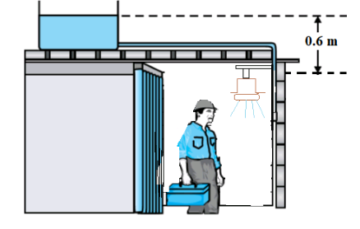

(i) Taking density of water = 1000 kg m–3, g= 10 N kg–1,

What is the water pressure at the showerhead? (2 mks)

(ii) What must the plumber do to increase the water pressure at the showerhead to 15,000 Pa?

(2mks)

3. Find the potential energy of an object of mass 350 g when it is 10 m above the ground. (4 mks)

4. Two forces of 17.2 N and 12.9 N act on a body at right angles to each other. Find the resultant force. (4 mks)

5. Friction force causes shoe soles, car tyres and moving parts of machinery to wear off.

(i) Therefore, what is meant by friction force. (1 mk)

(ii) State any three applications of friction force in our daily life. (3 mks)

6. Stability of a body is how easy or difficult a body will fall over (topple) when a force is applied on it.

(i) Deduce the factors that affect the stability of a body. (2 mks)

(ii) Suggest the different applications of stability of bodies in our daily life.

(2 mks )

**SECTION B**

7.(a). Every object exerts a given amount of weight when in contact with a given surface resulting into pressure onto the surface.

(i) Define the term pressure as applied to solids, and state its S. I unit. (2 mks)

(ii) Explain any two factors that affect pressure in solids. (2 mks)

b.(i) Describe any two applications of pressure in solids in our daily life.

(3 mks)

(ii) A metallic block of weight 100 N rests on a surface. Find the pressure exerted on the surface if the area of contact between the block and surface is 0.01 m2. (3 mks)

c.(i) Using the locally available materials in school, briefly describe an experiment to show that pressure in fluids is dependent on the the depth of the fluid. Clearly state your conclusion. (5 mks)

8.(a). The figure below shows the different categories of simple machines. These help us to do a lot of work and we can hardly live without them.

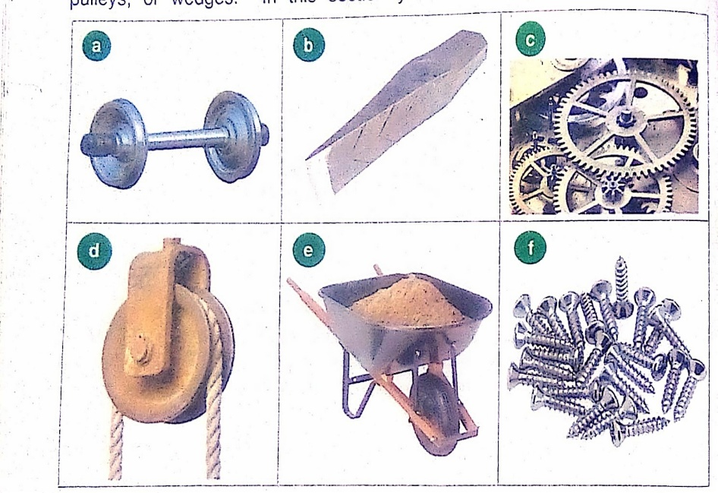

(i) what is meant by the term machine. (1 mk)

(ii) Identify the types of simple machines represented by pictures **b**, **c**, **d** and **e.**

(2 mks)

(b). Define the following terms as applied to simple machines:

(i) Mechanical advantage. (1 mk)

(ii) Velocity ratio. (1 mk)

(c). A wheel and axle machine has efficiency of 45%. If the radii of the wheel and axle are 20 mm and 2 mm respectively, find the;

(i) velocity ratio. (2 mks)

(ii) mechanical advantage. (3 mks)

(iii) effort used to lift a load of 10 N. (2 mks)

(d). State the classes of levers, giving at least one example of each class of levers stated. (3 mks)

9.(a). The figure below shows how the baby is able to see itself in a mirror because of reflection.

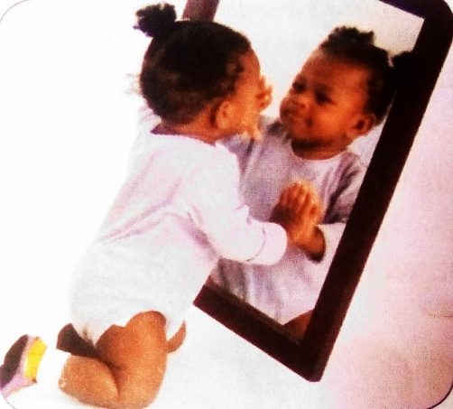

(i) Define the term reflection of light. (1 mk)

(ii) State the laws of reflection of light. (2 mks)

(b). Using simple illustrations, show how regular and irregular (diffuse) reflections occur. ( 3 mks)

(c).(i) A pinhole camera is a type of camera without a lens but with a small hole called aperture. State the properties of the images it forms. (2 mks)

(ii) Define an eclipse and state any two types of eclipses. (2 mks)

(d). The experiment below was carried out by S.3 students of ROCONA to study the nature of light.

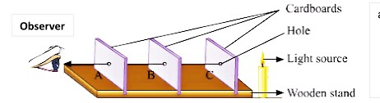

(i) Which property of light is being investigated by ROCONA Students? (1 mk)

(ii) Describe the procedure ROCONA Students followed when carrying out the above experiment. (4 mks)

10. (a). Zacharias is puzzled because his metallic doors are always very hard to close during day time when it is shining too much, and he says that the same doors are very easy to close in the evenings when the temperatures have lowered by considerable amounts. As a Physicist who understands better, the effect of temperature change on matter:

(i) Explain the cause of Zacharias' puzzle. (3 mks)

(ii) Describe any four applications of the cause stated in a(i) above in our daily life. (4 mks)

(b). Basing on the kinetic theory, explain why liquids expand much more than solids for the same temperature change? (4 mks)

(c). Explain the Biological importance of the anomalous expansion of water in preserving aquatic life in countries like Switzerland where temperatures go below 0o C, relating to the diagram shown below.

(4 mks)

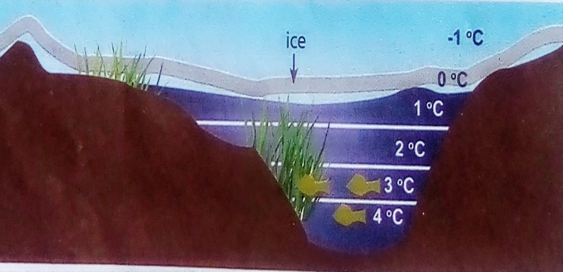

**Sir ENDMWP**

**Physics Department @** KAMOTA